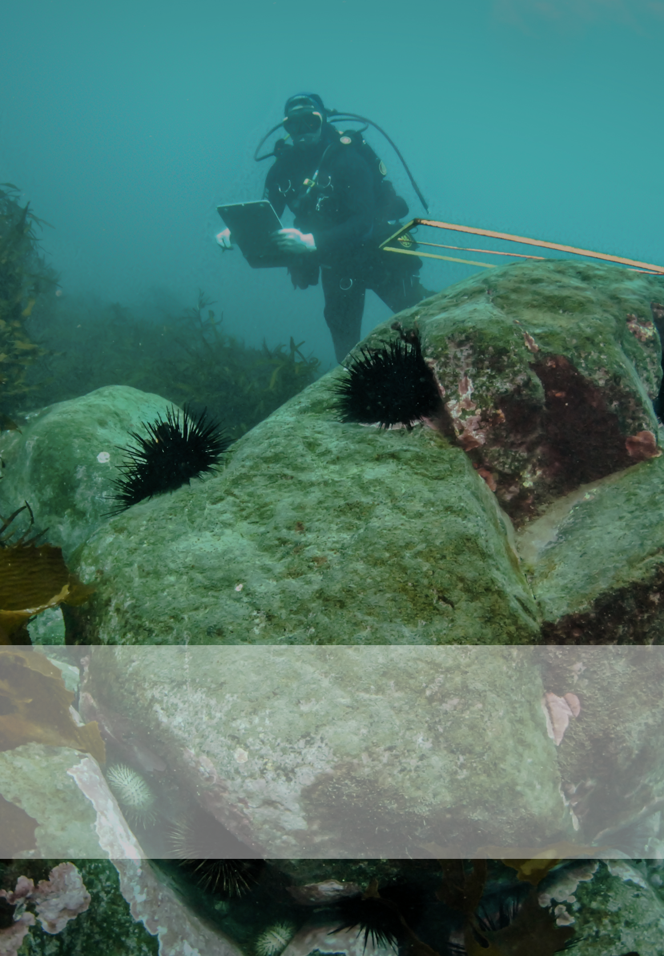

IMAS Data Submission Tool

**Home**  Help Sign In

**_____**



**Sign In**

**IMAS Data Submission Tool**

An open source tool for capturing research data - simplifying the process of gathering information in a standard format and preparing it for upload to the IMAS Data Portal.

What is Metadata?

*Metadata* is commonly known as ‘data about data’. It is the set of information that describes a data set, and includes details such as the name, format, context, content, and structure of the data. Metadata may also provide additional information related to the timing and location of the study, data quality and collection methods, contributors and funding bodies, and other useful information describing a data set.

How does the Data Submission Tool work?

The IMAS Data Submission Tool provides an intuitive user interface to collect metadata about research collections in a standardised format. With a simple one step log-in process, users can create metadata records and submit them with associated data file(s) for upload in the [IMAS Data Portal](http://data.imas.utas.edu.au/). All draft, submitted, and uploaded records can be managed by users on their personalised [dashboard page](http://data.imas.utas.edu.au/submit/dashboard/).

Using this guide

This User Guide is intended to provide a comprehensive overview of understanding and using the IMAS Data Submission Tool. We recommend you refer to the guide as a set of practical instructions to help you work through the steps of completing your first metadata record. You can navigate to any part of the guide via the summary of contents on the next page of this document.

Questions & comments

If you have any queries or require additional information to be included in your metadata, please email [IMAS.DataManager@utas.edu.au](mailto:IMAS.DataManager@utas.edu.au). This may include specific comments regarding the format required for citing the data, a Digital Object Identifier, or any other information not captured by the Data Submission Tool.

This (meta)data collection tool is currently in its infancy, and we welcome all comments to assist with its improvement. Please direct all general comments and queries to [IMAS.DataManager@utas.edu.au](mailto:IMAS.DataManager@utas.edu.au).

* ***IMAS Data Team***

Contents

|  |  |
| --- | --- |
| **Sign Up / Sign In** | 1 |
| **Creating a new record** | 2 |
| **Managing your records / Housekeeping** | 3 |
| **Finding your way around** | 4 |
| **TAB 1: IDENTIFYING** the data | 5 |
| **TAB 2: WHAT** was collected | 6 |
| **TAB 3: WHEN** was the data collected | 8 |
| **TAB 4: WHERE** was the data collected | 9 |
| **TAB 5: HOW** was the data collected | 11 |
| **TAB 6: WHO** collected the data | 12 |
| **TAB 7: ABOUT** the data file (including licensing) | 14 |
| **TAB 8: UPLOAD** data file(s) | 16 |
| **TAB 9: LODGE** your metadata draft | 17 |
| **What next?** Archiving data for public discovery | 17 |

# Create a user account / Sign in

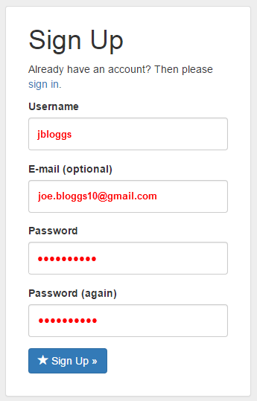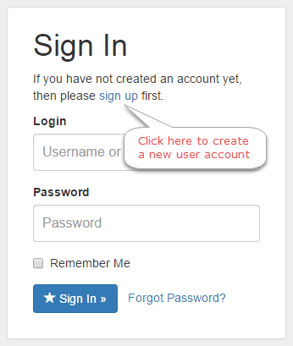

Sign in

SIGN IN on cover page

# Create a new Metadata record

Create new record

**My Records**

Select IMAS Metadata as the document template. This is currently the only metadata template available, but the list of templates may expand over time.

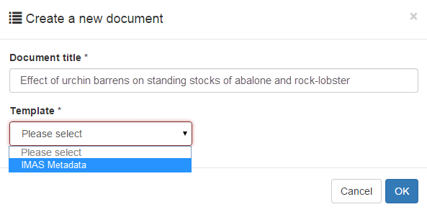

# Managing your records / Housekeeping

View a complete list of all your metadata records on your personal dashboard. The checkboxes to the right enable filtering by status of the record (Draft, Submitted, Uploaded or Archived). By default this page will display **Draft** and **Submitted** records. Note that if you accidentally delete a record, it is recoverable from the **Archived** section.

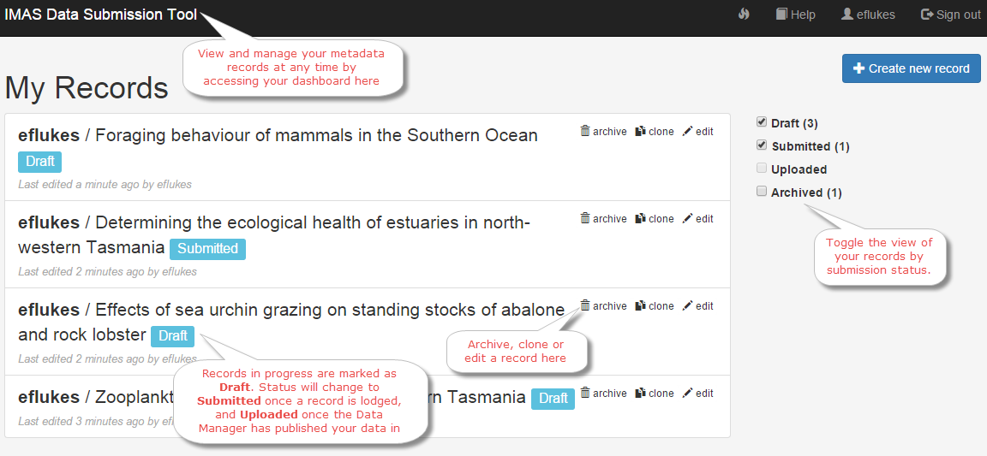

# Finding your way around

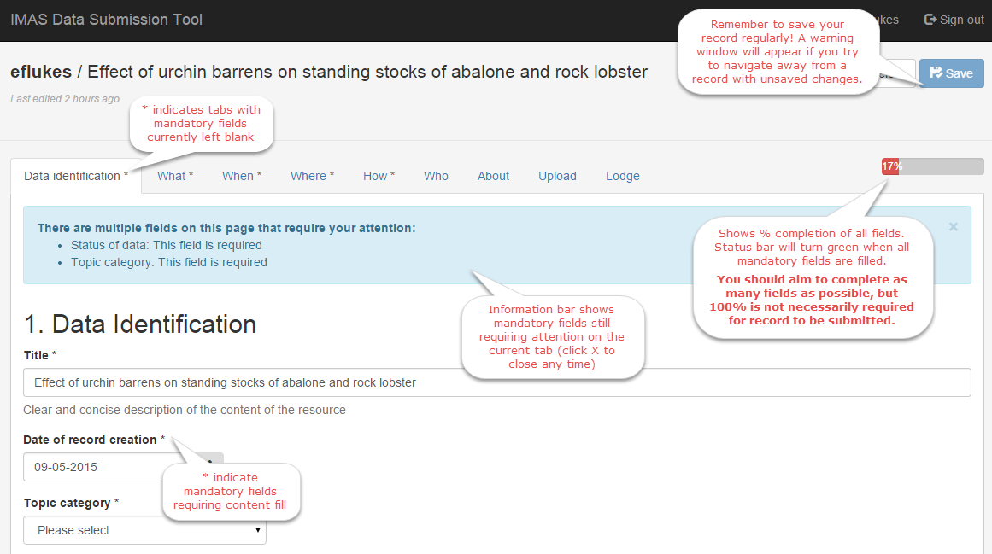

## TAB 1: Data Identification

Complete all fields using the prompts provided. Asterisks (*) will clear from tab headings once all mandatory fields have been filled.

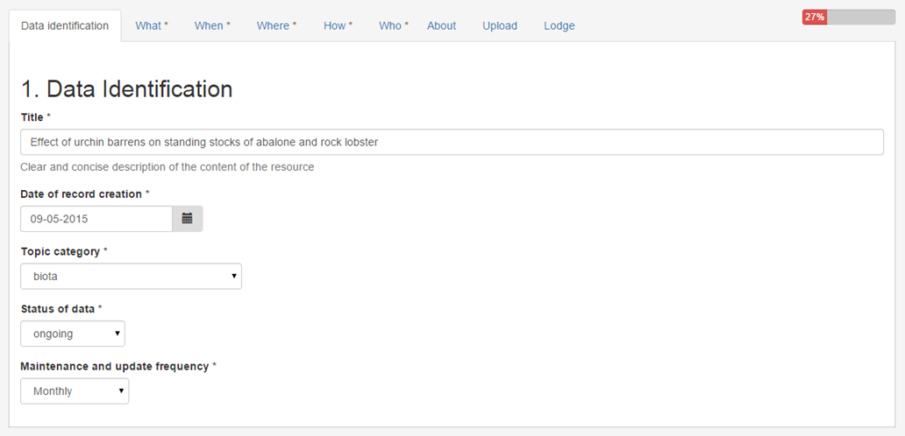

Frequency of updates to the **data**.

This will be disabled if data is marked as ***complete*** at the previous step.

## TAB 2: What

Provide a brief abstract of the data set and add some keywords to describe the data. Search for keywords in the inbuilt thesaurus by typing in the search box, or click the ***Browse*** button to expand the full alphabetical list of available keywords.

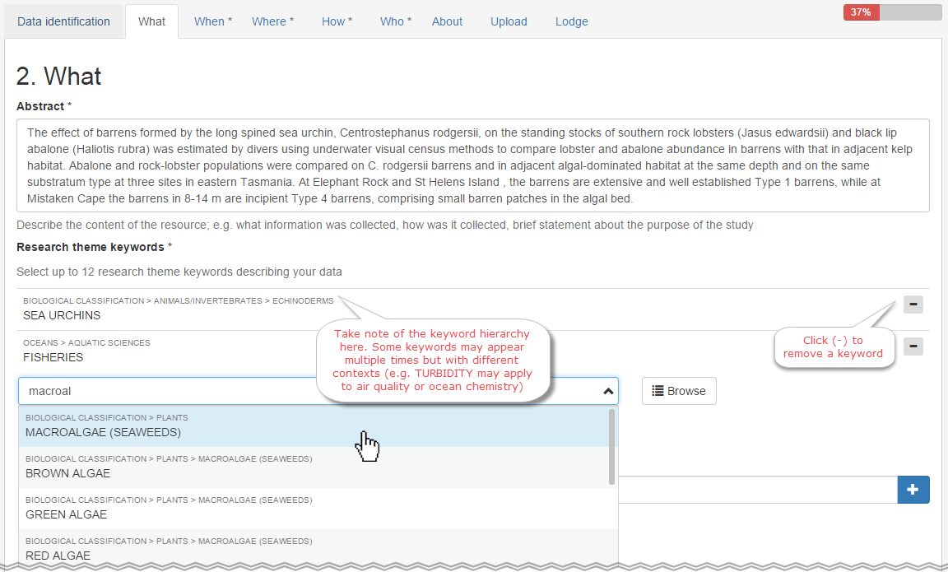

**TAB 2: What (continued)**

List additional free text keywords if required (note: try searching for theme keywords using the inbuilt thesaurus before typing your own). Add any relevant taxon keywords. Check the spelling carefully as taxon keywords will be used in search functions to discover your data.

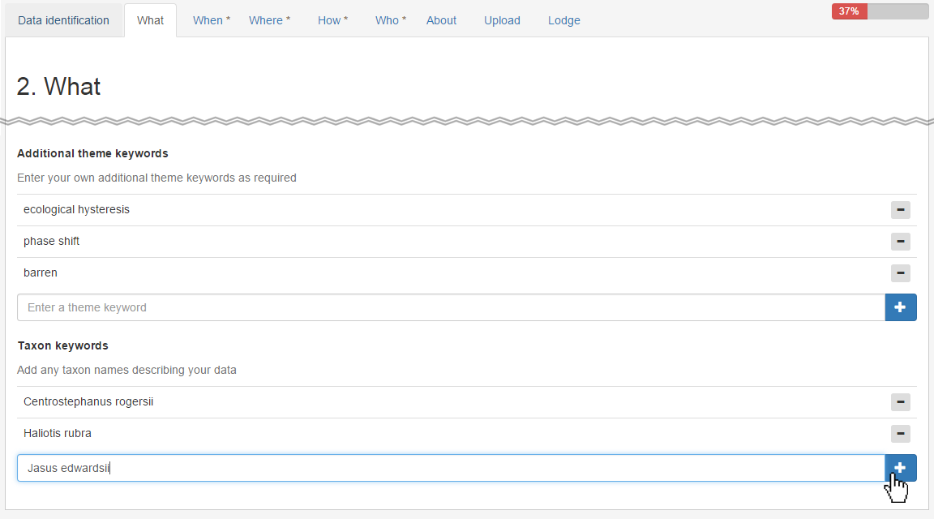

## TAB 3: When

Select a start and end date for the duration of data collection.

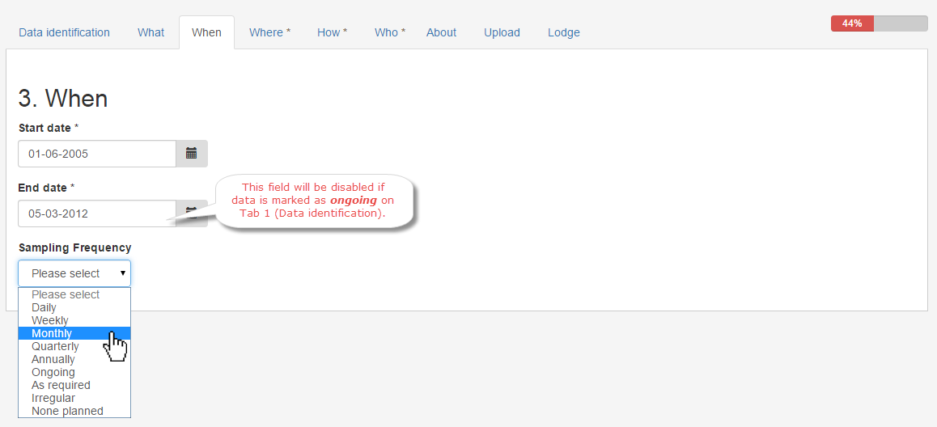

## TAB 4: Where

Describe the spatial coverage of the data. Note that for laboratory experiments this can include the site(s) of specimen collection. If data has no relevant spatial context, untick “Does data have a geographic coverage?".

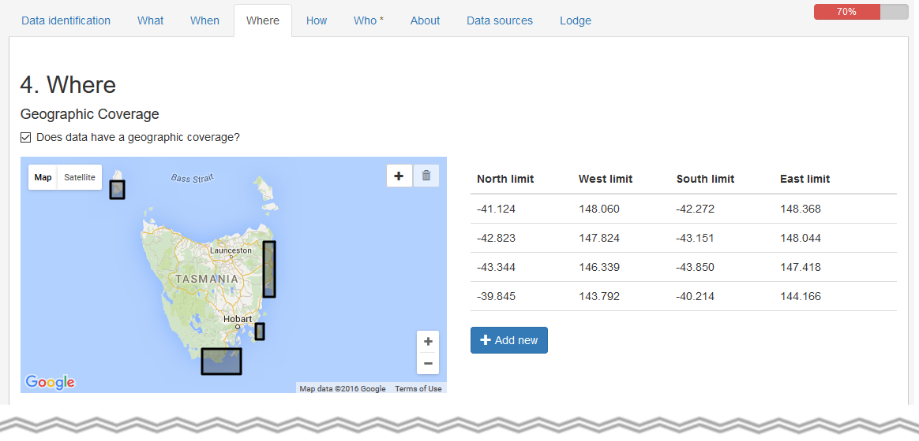

Click the plus symbol to create a spatial bounding box, or manually enter coordinates by clicking ***Add New***.

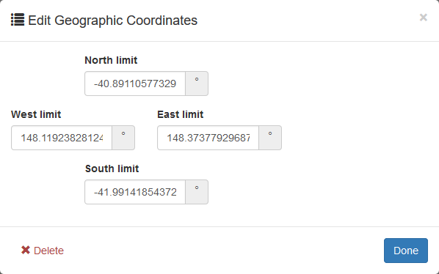

To delete a bounding box, click the row of numbers to open the edit coordinates screen and choose ***Delete*** from the bottom left corner

**TAB 4: Where (continued)**

Add any relevant vertical spatial information (depth, or height above sea level i.e. altitude). Note that if the ***vertical coverage*** box is not ticked, the other vertical extent descriptors will disappear.

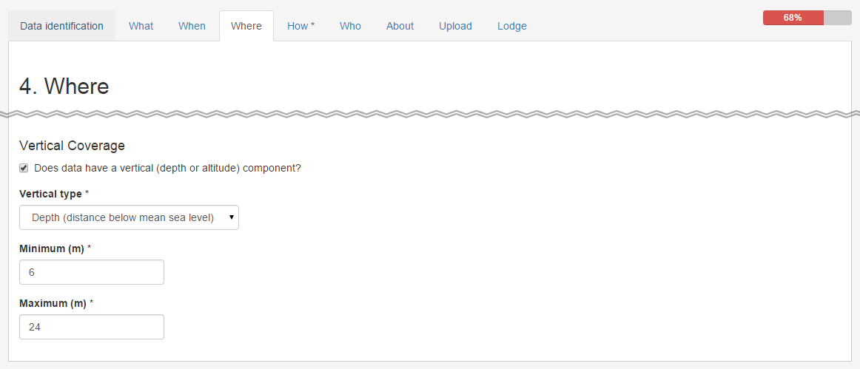

## TAB 5: How

Briefly describe the methodology of the data collection. A reference to a published report or paper may be provided if additional information is required.

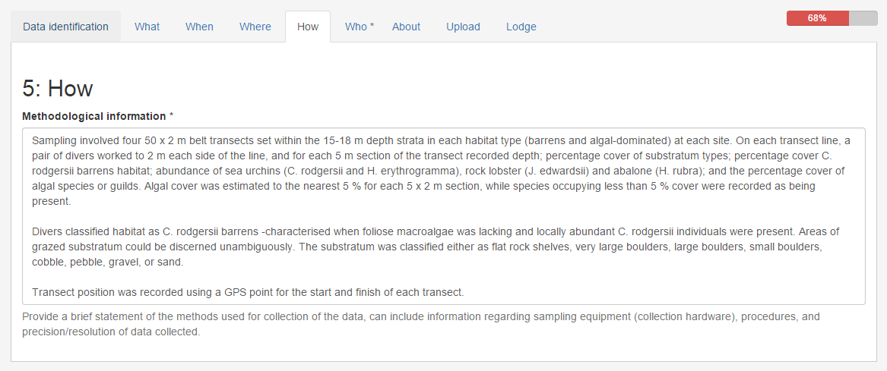

## TAB 6: Who

Add at least one Point of Contact for the data set. The Point of Contact should be able to answer any enquiries relating to the data, or redirect the enquiries to the appropriate person. Add the details of all Responsible Parties associated with the data set (note that this may be the same as the Point of Contact). A Responsible Party is usually involved with the collection of the data, but may also be a distributor or custodian of the data.

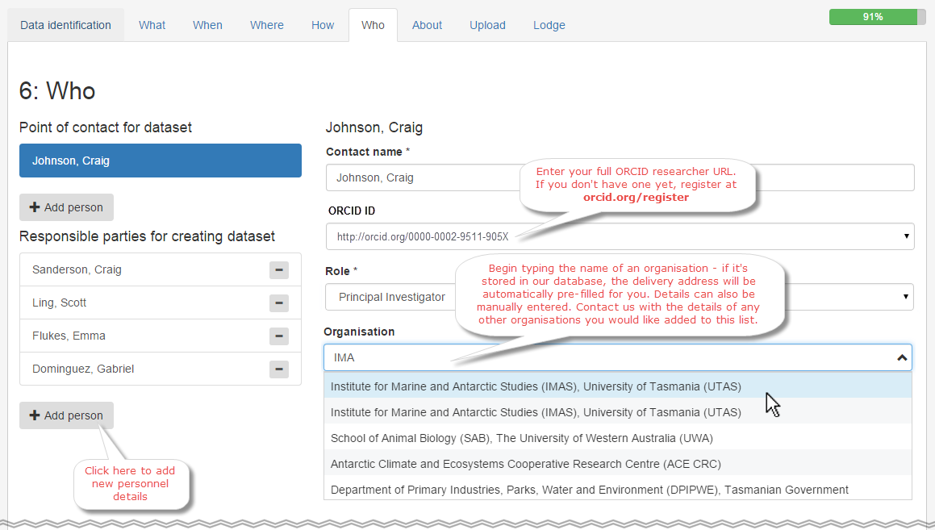

[orcid.org/register](https://orcid.org/register)

**TAB 6: Who (continued)**

Add the credits of any additional organisations associated with the data collection.

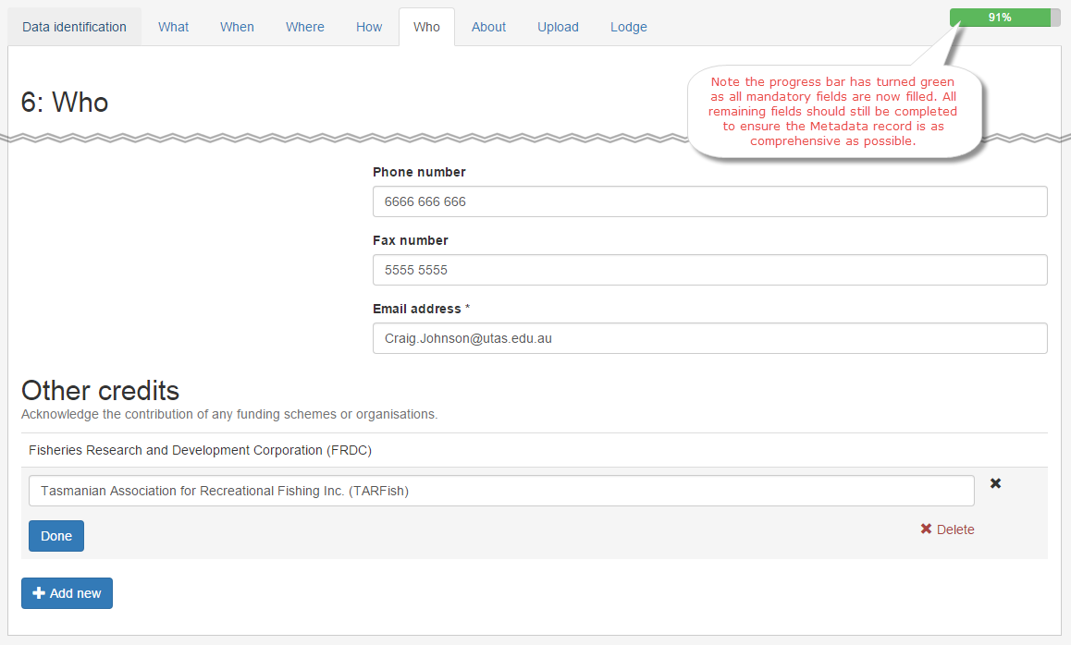

## TAB 7: About

Describe all measured parameters contained in the data set (hint: this is typically the names of your data columns), including units of measurement. If parameter names are abbreviated in the data file, include both the abbreviated name and a full description of the parameter name. Provide additional information on data parameters if required.

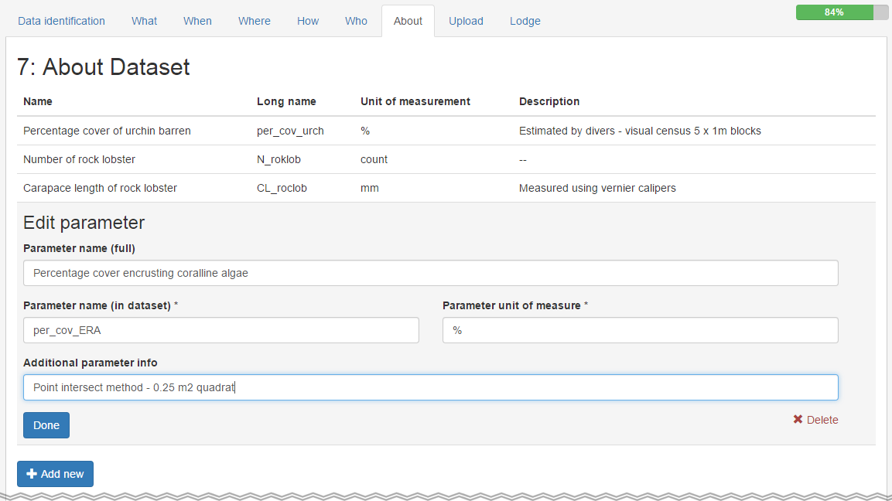

**TAB 7: About (continued)**

Choose the appropriate Creative Commons (CC) license for your data. All CC licenses require work to be attributed (cited). If this is the only necessary stipulation for use of your data, we recommend Creative Commons by Attribution (CC-BY). If you have additional stipulations for the use of your data (e.g. non-commercial purposes, no derivative works), choose ***CC non-commercial*** or ***other*** and list any additional requirements.

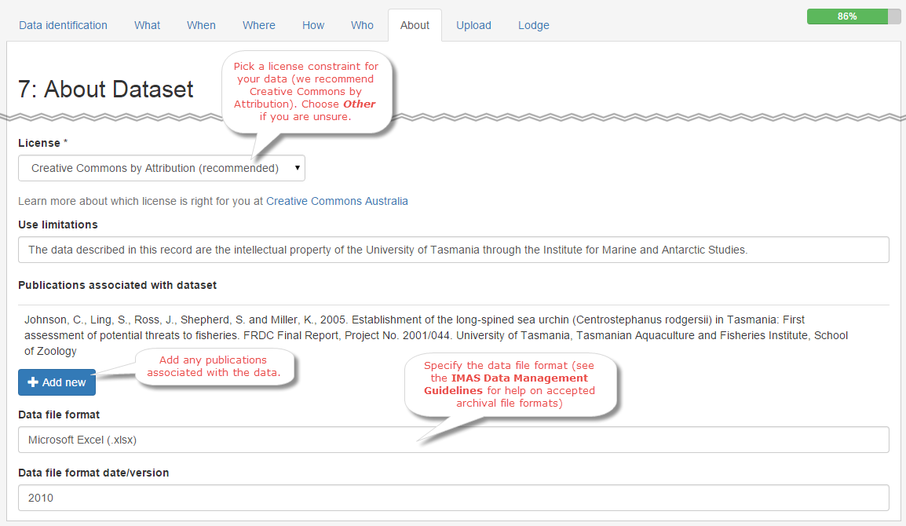

## TAB 8: Upload

Upload any data associated with the metadata record. This will typically be a single CSV file, but may also involve multiple files and a variety of different file formats. You may also upload any additional supporting information here (e.g. project reports, important methodological images, database schema diagrams etc.). File uploads have a maximum size of 20 MB. If your data file(s) are larger than 20 MB, proceed with the submission process as normal and reply to the confirmation email (sent when your metadata is lodged) with details of any additional files you wish to submit.

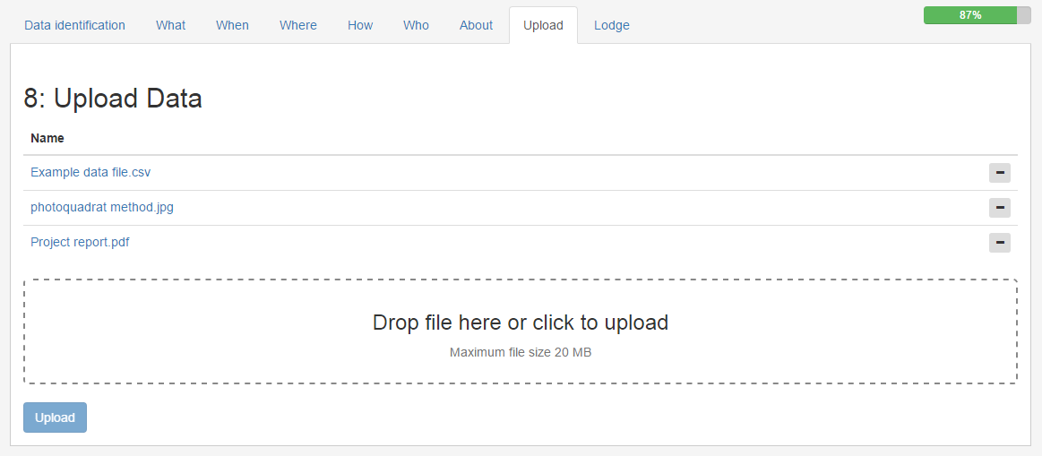

## TAB 9: Lodge metadata draft

If you have successfully completed all mandatory fields, your record will be ready to lodge (note that you will be unable to lodge the record if any mandatory fields have been left blank). The progress bar may not show 100% if some optional fields have been left blank (e.g. fax numbers, additional credits, data file versions etc. if not applicable). Have a quick check over your record and ensure you have completed as many fields as possible.

Happy? Hit lodge… and you’re done!

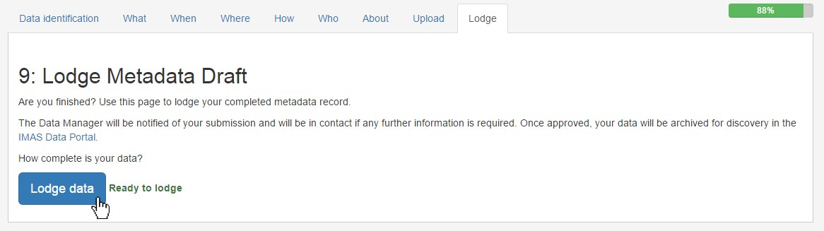

# What next?



Once lodged, your record will be marked as on your [dashboard page](http://data.imas.utas.edu.au/submit/dashboard/) and you will receive an email confirming your submission. The IMAS Data Manager will review your submission and be in touch to request any additional information if required. You can reply directly to your confirmation email with any queries, comments, or details of additional large data files you wish to submit. When your record has been approved, it will be uploaded to the [IMAS Data Portal](http://data.imas.utas.edu.au/) for discovery. You will receive an email notifying you of its approval and the record’s status will change to on your documents dashboard.

Records may still be modified following submission, but once the record is uploaded to the IMAS Data Portal you will no longer be able to edit it. If you need to modify an uploaded record, contact the IMAS Data Manager ([IMAS.DataManager@utas.edu.au](mailto:IMAS.DataManager@utas.edu.au)) to notify them of any required changes.